K. Rajeswari Profile
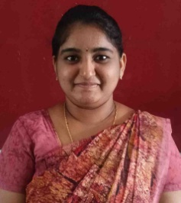
- Name : K. Rajeswari
- Designation : Lecturer in Chemistry
- Date of Birth : 31 – 12 - 2000
- Educational Qualifications : M. Sc.
- Teaching experience : 1Year
- Research Experience : NIL
- Dissertation/Thesis Title : NIL
- No. of Research publications : NIL
- No. of Books Published : NIL
- No. of Major/Minor Research Projects: NIL
- Title of Minor Research Project : NIL
- No .of International Conferences Attended : NIL
- No. of National Conferences Attended : NIL
- No. of Papers Presented at the Seminars/Conferences: NIL
- Refresher Courses/Orientation Programs/Training Programs Attended: NIL
- Vidwaan Score : NIL
- Address : D/O Dhana Vishnu,
Tamarada, Penugonda,
West Godavari - 534324
- E-mail Id : rajeswarikodelli7@gmail.com
- Contact No : 9110551210

